SCHOOL OF COMPUTER SCIENCE AND ARTIFICIAL INTELLIGENCE |  |  |  |  |  | DEPARTMENT OF COMPUTER SCIENCE ENGINEERING
 | Program Name: B. Tech |  |  |  | Assignment Type: Lab |  |  | Academic Year:2025-2026
 | Course Coordinator Name |  |  |  | Dr. Rishabh Mittal
 | Course Code |  |  | 23CS002PC304 | Course Title |  | AI Assisted Coding
 | Year/Sem |  |  | III/II | Regulation |  | R23
 | Date and Day  of Assignment |  |  | Week3 – Wednesday | batch |  | 48
 | NAME |  |  | Y.PranithSai | HALLTICKET.NO |  | 2303A54072
AssignmentNumber: 6.3
 |  | .
 |  | 1 | Lab 6: AI-Based Code Completion – Classes, Loops, and Conditionals  Task Description #1: Classes (Student Class)  Scenario  You are developing a simple student information management module.  Task: Create a Student class with name, roll number, and branch, and display student details.  Prompt Used  Generate a Python class named Student with attributes name, roll number, and branch. Add a method to display student details.  Sample Input:  Name =  Roll Number =  Branch =  Sample Output:  Name: :Praniith Sai  Roll Number: 101  Branch: CSE  Short Explanation:  This program uses a class to store student details the constructor initializes values and the method print them neatly  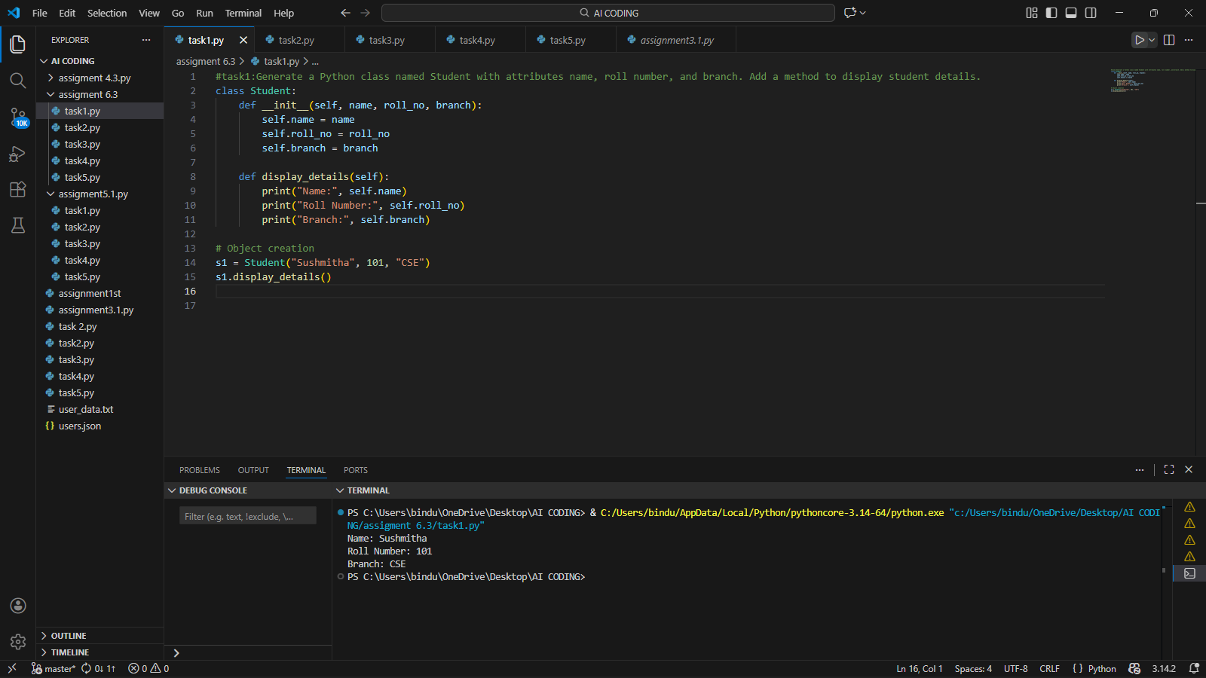  Task Description #2: Loops (Multiples of a Number)  Scenario  You are writing a utility function to display multiples of a given number.  Task: Print the first 10 multiples of a given number using loops.  Prompt Used: Generate a Python function to print first 10 multiples of a number using for loop and while loop.  Sample Input:  5  Sample Output:  5  10  15  20  25  30  35  40  45  50  Short Explanation: Both loops repeat the same task.  The for loop is shorter, while the while loop gives more control over conditions.  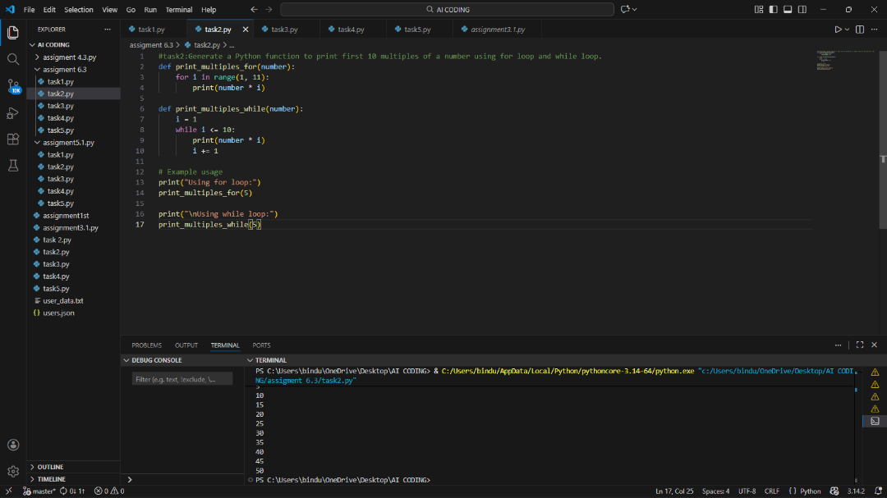  Task Description #3: Conditional Statements (Age Classification)  Scenario  You are building a basic classification system based on age.  Task  Classify age into child, teenager, adult, or senior.  Prompt Used: Write Python code using if-elif-else to classify age groups.  Sample Input: 20  Sample Output: Adult  Short Explanation: The program checks age step by step using conditions and prints the correct group.  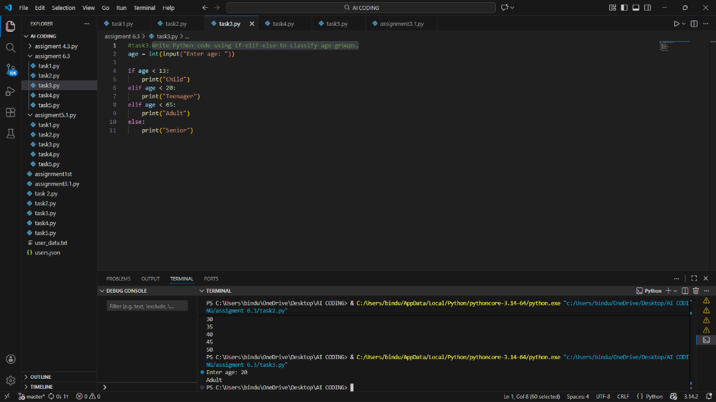  Task Description #4: For and While Loops (Sum of First n Numbers)  Scenario  You need to calculate the sum of the first n natural numbers.  Task  Calculate the sum of first n natural numbers.  Prompt Used: Generate a Python function to calculate sum of first n numbers using for loop and while loop.  Sample Input: Sum of first 10 numbers using for loop: 55  Sample Output  Sum of first 10 numbers using while loop: 55  Short Explanation  Both methods add numbers from 1 to n.  The logic is simple accumulation using loops.  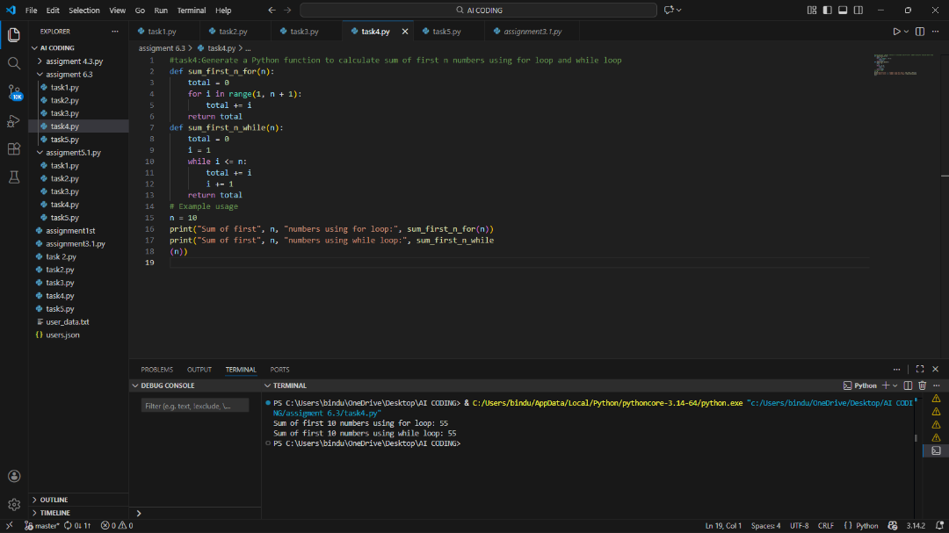  Task Description #5: Classes (Bank Account Class)  Scenario  You are designing a basic banking application.  Task  Create a Bank Account class with deposit, withdraw, and check balance.  Prompt Used:  Generate a Python BankAccount class with deposit, withdraw, and balance checking methods.  Sample Input  Initial Balance = 1000  Deposit = 500  Withdraw = 300  Sample Output:  Deposited: 500  Withdrawn: 300  Current Balance: 1200  Short Explanation  This class manages bank operations.  It updates balance safely and checks conditions before withdrawing money.  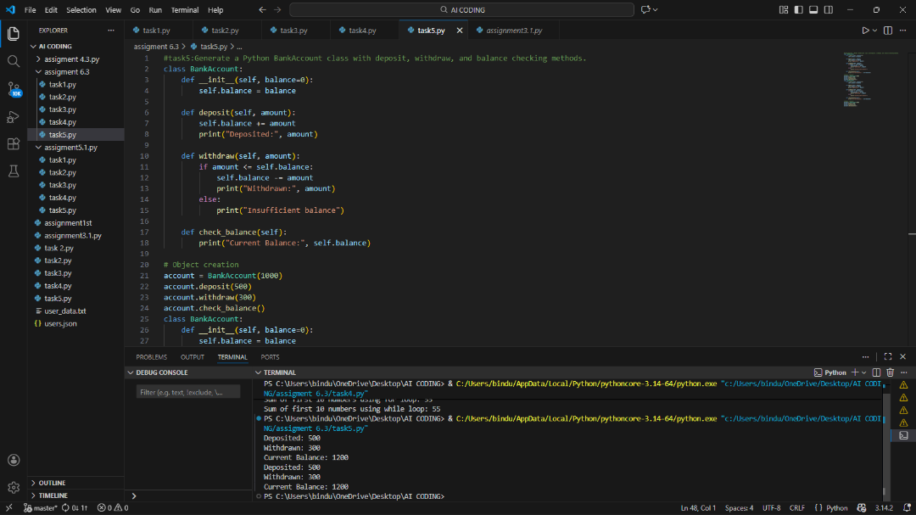 |  |  |  |  |  | Week3 - Wednesday

